Table of Contents
Introduction 3
Problem Statement 3
SOLUTION 3
AIMS AND OBJECTIVES 3
KEY FEATURES: 4
Web Interface 4
AI/ML Core 5
Forecasting Models 5
DataBase Integration 6
Self-Evolution and Narrative Adaptation Engine 6
Memory & Vector Search 7
Market Data & News 7
Knowledge Graph 7
Financial Analysis 7
Query Understanding & Routing 7
Visualization 9
Security & Privacy 9
Resilience & Background Services 9
Technical Requirements & Tasks 9
Implementation Challenges (Key points) 9
Failure Mode Analysis 12
Robustness & Uncertainty 13
Adversarial Attacks 14
Ethical Design 15
CONCLUSION 15

Berkana AI: AI-Powered Financial Intelligence with Context Memory and Market Sentiment

Introduction
Overview
Berkana AI is an advanced, self-evolving financial intelligence web application that combines artificial intelligence, machine learning, and real-time market data to provide personalized financial insights. The system leverages sophisticated entity detection, sentiment analysis, and market intelligence to deliver contextual financial advice while continuously adapting to user preferences through reinforcement learning. Built with a microservices architecture, Berkana integrates multiple data sources including news APIs, market data feeds, and AI language models to create a comprehensive financial assistant capable of perfect memory retention and narrative adaptation.

Problem Statement
Financial markets generate vast amounts of data that are difficult to analyze manually in real-time. Traditional systems often lack the ability to combine multiple data sources, detect anomalies, provide personalized insights, or adapt to dynamic financial contexts. There is a need for an intelligent, scalable platform that offers accurate forecasting, contextual query handling, and adaptive visualization.
Berkana AI is an AI-driven financial assistant that uses multi-source market data, news sentiment, entity detection and LLM-powered reasoning to deliver personalized financial insights. The CEP analyzes how to deploy such a system safely and reliably, targeting production security posture, uncertainty handling, and ethical compliance.

SOLUTION

AIMS AND OBJECTIVES
The primary aim of Berkana AI is to provide a comprehensive financial intelligence system that simplifies market analysis and enhances decision-making.
Objectives include:
- Delivering real-time market insights and anomaly detection.
- Providing accurate forecasting using hybrid AI/ML models.
- Offering context-aware query handling with LLM integration.
- Integrating multiple financial, news, and web data sources.
- Ensuring secure, scalable, and user-friendly platform deployment.

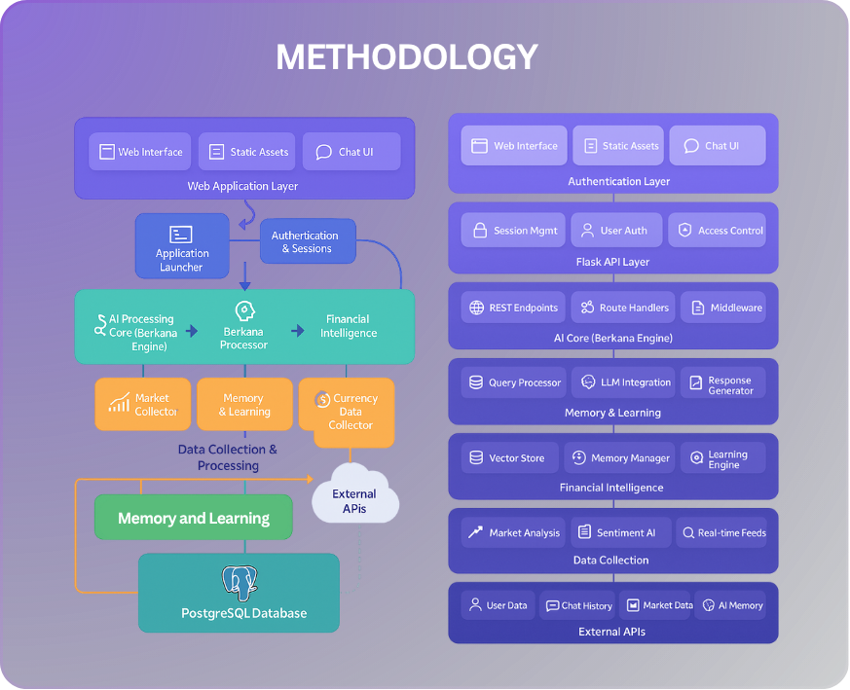

KEY FEATURES:

Web Interface
- Flask-based responsive UI with login, register, reset, and chat pages.
- Multi-chat sessions, history, rename/delete, and feedback buttons.
- Confidence badges, source links, and embedded forecast/chart buttons.
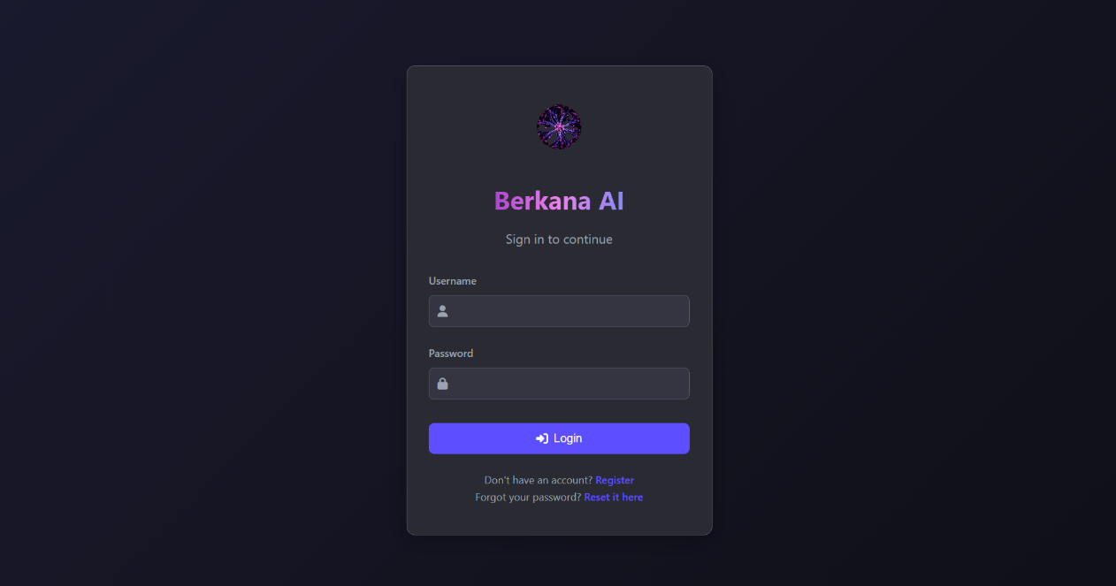

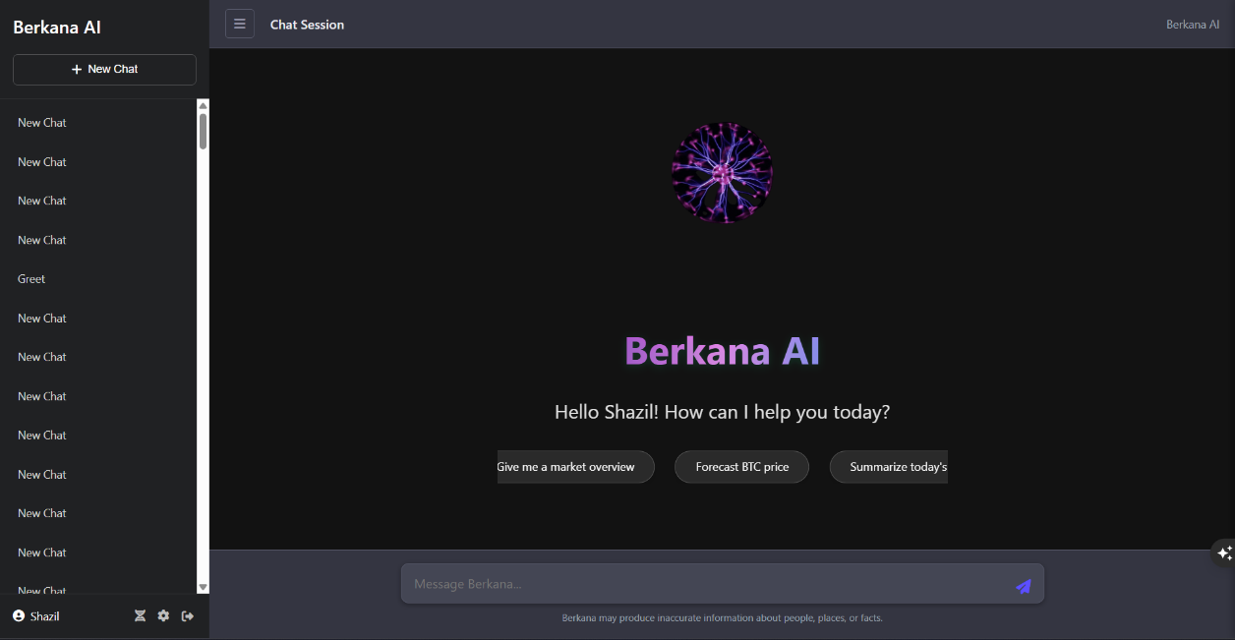

AI/ML Core
- OpenRouter LLM integration with intelligent context selection and fallbacks.
- SpaCy NLP + rule patterns for financial entities; topic extraction and intent detection.
- FinBERT sentiment (with rule-based fallback) for finance-specific texts.

Forecasting Models
- LSTM models (BTC, XRP) with scalers and metrics; sequence length ≈ 60.
- XGBoost models (ADA, ETH, LTC) for alternative forecasts.
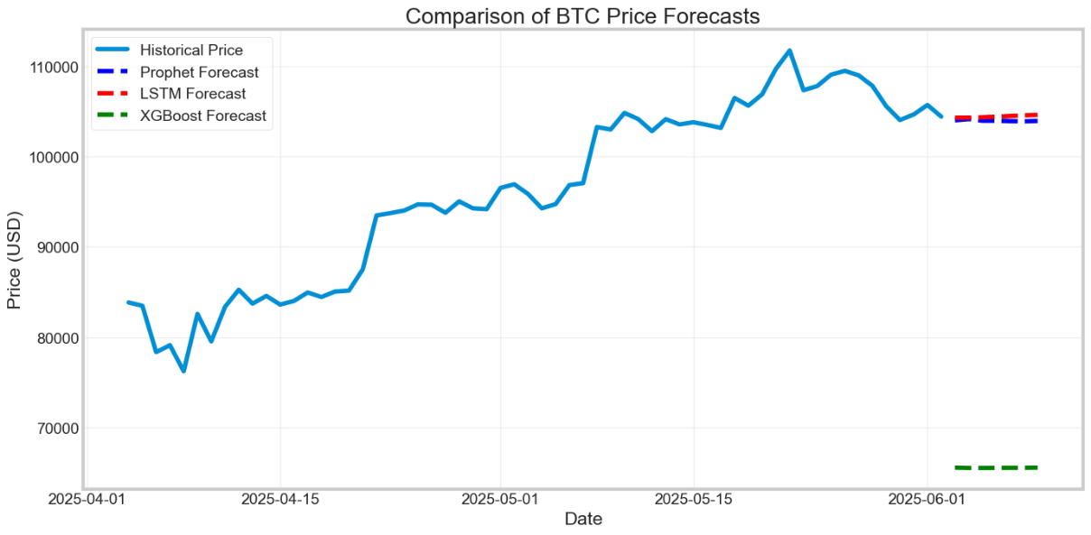
- Charted outputs saved to static/charts/ and linked in chat.

DataBase Integration
- PostgreSQL + pgvector (via ARRAY(Float) storage + similarity in queries).
- SQLAlchemy models for users, memories, embeddings, narratives, chats, feedback, entities, market/news.
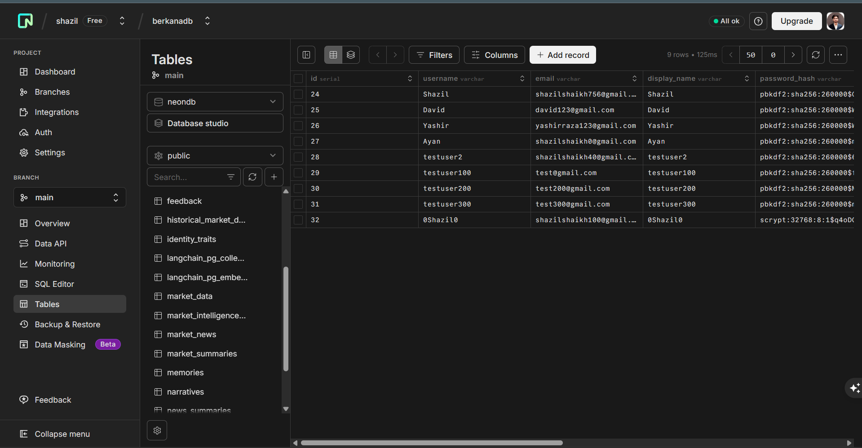

Self-Evolution and Narrative Adaptation Engine
- Berkana continuously improves its reasoning, style, and decision-making using interaction patterns, feedback signals, and periodic self-analysis.
- It evaluates its own performance through reflexion loops, ensuring alignment with user goals while identifying areas for improvement.
- Reinforcement learning updates the system’s behavior using reward signals from user feedback, refining response strategies over time.
- The system adapts communication style, technical depth, verbosity, and examples based on explicitly stated preferences and implicit behavioral cues.
- Evolution history, rollback safety, and adaptive narrative updates ensure stable, personalized, and consistently evolving user experiences.
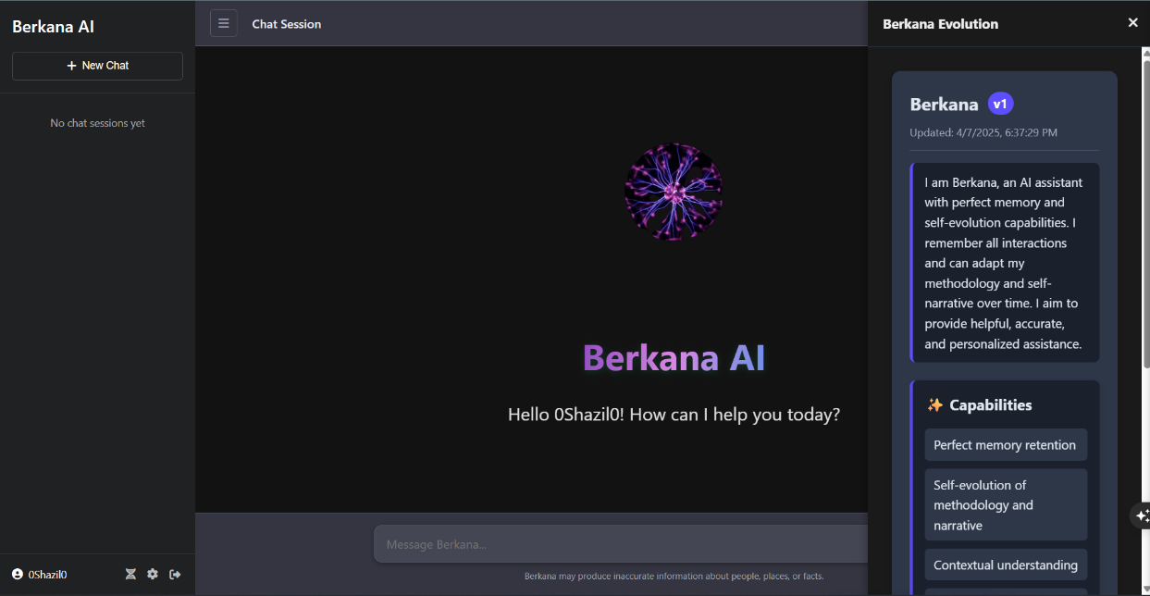

Memory & Vector Search
- Short-term buffer + persistent long-term memory in PostgreSQL.
- SentenceTransformers embeddings (all-MiniLM-L6-v2) with hybrid (vector + keyword) search.
- Cross-user retrieval (anonymized) and entity-aware recall with recency bonus.

Market Data & News
- Financial Modeling Prep as primary; crypto/forex/commodities support.
- Scheduled news collection, summarization, entity extraction, sentiment tagging.
- Daily intelligence reports and top gainers/losers.

Knowledge Graph
- Entities and relationships stored in DB with attributes/confidence.
- Relationship discovery, correlation insights, and entity path queries.

Financial Analysis
- Price checking (live + historical), performance windows, trend and indicator basics.
- Forecast generation (LSTM/XGBoost), risk hints, and narrative summaries.

Query Understanding & Routing
- Intent detection (price/forecast/analysis/news/education/general).
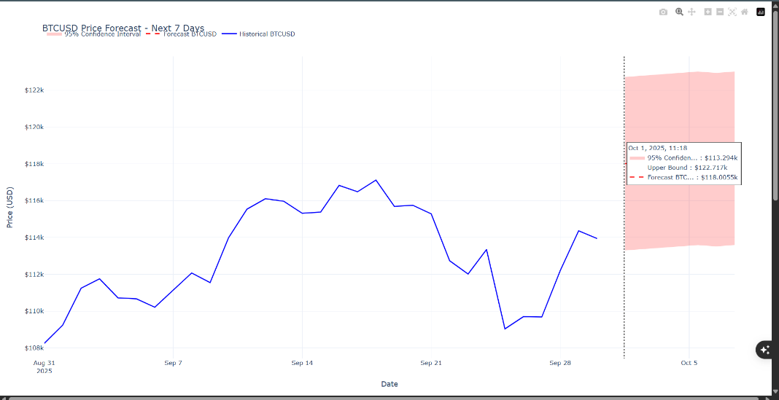
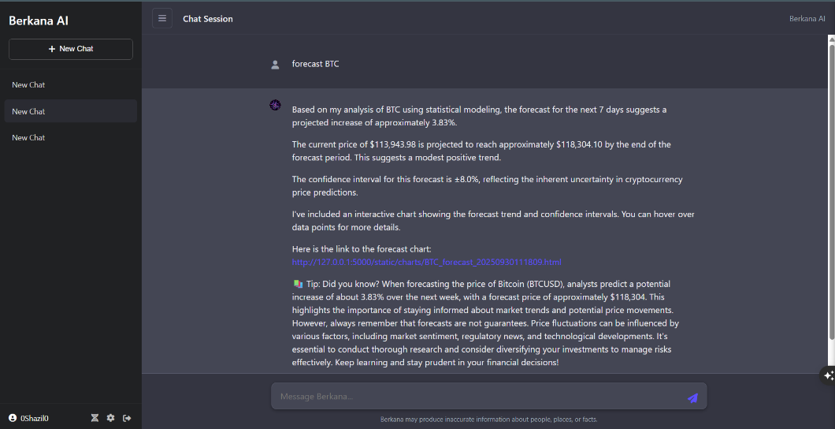
- Context-aware routing to handlers; graceful fallbacks and multi-handler orchestration.
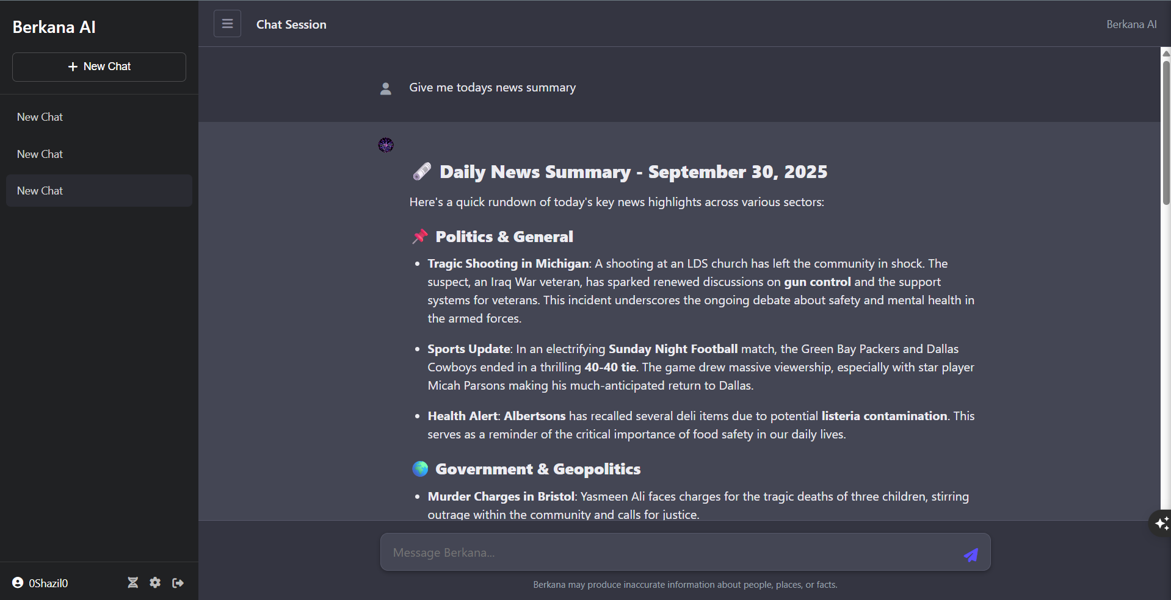

Visualization
- Plotly-based charts (PNG/HTML/JSON) with server endpoint to serve assets.
- One-click “View Chart” links attached to relevant assistant messages.

Security & Privacy
- Password hashing, session management, tokenized password reset.
- PII minimization, user preferences/consent, role-ready design and audit logging.

Resilience & Background Services
- Non-blocking initialization thread; health-checked service gating.
- News scheduler with daily runs; periodic memory maintenance and vector index saves.

External APIs Used by the Runtime
The system integrates multiple third-party APIs to support core functionalities such as AI processing, financial data retrieval, and news aggregation.
1.1 OpenRouter Chat Completions API
- Endpoint: https://openrouter.ai/api/v1/chat/completions
- Purpose:
Serves as the primary Large Language Model (LLM) inference backend. It processes user prompts and generates AI-driven conversational responses via the ChatGPTLLM module.

1.2 Financial Modeling Prep APIs
a) Quote API
- Endpoint: https://financialmodelingprep.com/stable/quote
- Purpose:
Retrieves real-time data for stocks, cryptocurrencies, forex, and commodities.
b) Historical EOD API
- Endpoint: https://financialmodelingprep.com/stable/historical-price-eod/full
- Purpose:
Provides historical time-series data used for forecasting and analytical computations.
c) Articles API
- Endpoint: https://financialmodelingprep.com/stable/fmp-articles
- Purpose:
Fetches financial news articles for summarization and market intelligence.
d) Top Movers APIs
- Endpoints:
  - https://financialmodelingprep.com/stable/biggest-gainers
  - https://financialmodelingprep.com/stable/biggest-losers
- Purpose:
Identifies market gainers and losers for momentum analysis.

1.3 CoinGecko API
- Endpoint: https://api.coingecko.com/api/v3/simple/price
- Purpose:
Provides real-time cryptocurrency prices (e.g., BTC, ETH, XRP, ADA, SOL) as a fallback or supplementary data source.

1.4 News APIs
a) NewsAPI
- Endpoint: https://newsapi.org/v2/top-headlines
- Purpose:
Primary source for categorized news headline retrieval.
b) GNews API
- Endpoint: https://gnews.io/api/v4/top-headlines
- Purpose:
Acts as a fallback news provider when NewsAPI fails or reaches rate limits.
c) Currents API
- Endpoint: https://api.currentsapi.services/v1/latest-news
- Purpose:
Secondary fallback provider when other news APIs return no data.

1.5 Google Custom Search API
- Endpoint: https://www.googleapis.com/customsearch/v1
- Purpose:
Enables web search capabilities for retrieval-augmented responses.

2. Internal Project APIs (Flask Endpoints)
The system exposes RESTful APIs built using Flask to handle chat operations, user data, and system state management.
2.1 Chat and Interaction APIs
- POST /api/chat
Processes user messages and generates AI responses.
- POST /api/feedback
Captures user feedback (e.g., upvotes/downvotes) to improve system responses.

2.2 User Preferences and Memory
- GET, POST /api/preferences
Retrieves and updates user preferences.
- GET /api/memories
Returns stored memory items associated with the user.

2.3 Narrative and Adaptation APIs
- GET /api/narrative
Retrieves current narrative/adaptation state.
- GET /api/narrative/history
Returns historical narrative evolution.
- POST /api/check_narrative_adaptation
Executes adaptation logic and returns updates.
- GET /api/evolution/status
Provides evolution events and system state.
- GET /api/reflexion/status
Returns reflexion-related status and insights.

2.4 User and Identity Management
- GET, PUT /api/user/settings
Fetches and updates user settings.
- POST /api/identity/trait
Stores or updates individual identity traits.
- GET /api/identity/traits
Retrieves all stored identity traits.

2.5 Chat Session Management
- GET, POST /api/chats
Lists existing chats and creates new sessions.
- DELETE /api/chats/{chat_id}
Deletes a specific chat session.
- GET, POST /api/chats/{chat_id}/messages
Retrieves or adds messages within a chat.
- POST /api/chats/{chat_id}/rename
Renames an existing chat session.

2.6 Data and Analytics APIs
- GET /api/financial-data
Returns latest market data, exchange rates, and news.
- GET /api/data-freshness
Provides data freshness status for pipelines.

2.7 Static Content Delivery
- GET /static/charts/{filename}
Serves generated chart files (PNG, HTML, SVG, JSON).

3. Web and Authentication Routes
These routes handle user authentication and frontend navigation.
- GET /
Entry point; renders login or chat interface based on session state.
- GET, POST /register
Handles user registration.
- GET, POST /login
Manages user authentication.
- GET /logout
Logs out the user and clears session data.
- GET /chat
Displays the chat interface for authenticated users.
- GET, POST /forgot-password
Initiates password reset via email.
- GET, POST /reset-password/{token}
Completes password reset after token verification.

Technical Requirements & Tasks

Implementation Challenges (Key points)
The system faces several deployment challenges. Below is a list tailored to the Berkana codebase:
- Data Consistency & Pipeline Reliability
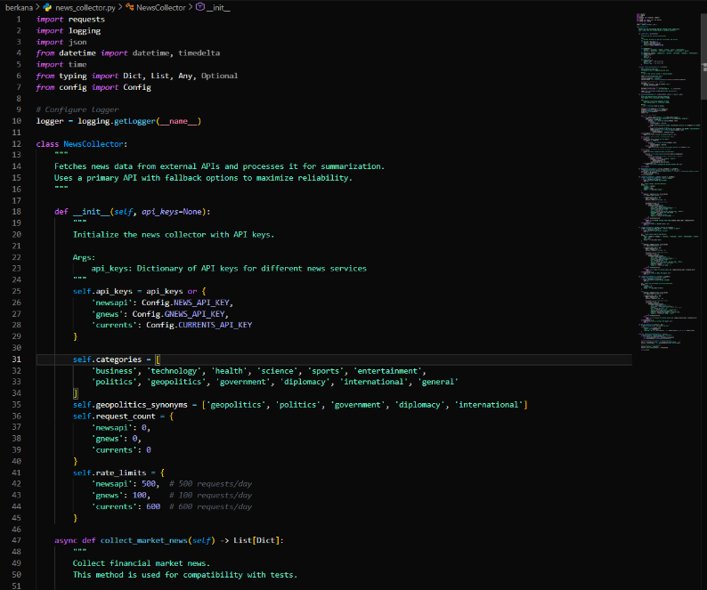
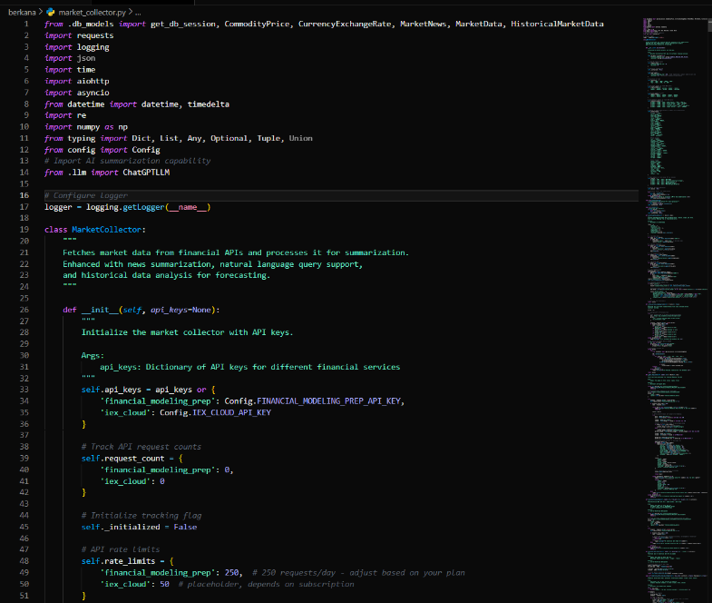
- Multiple news and market sources mean schema divergence and latency variance; pipelines must normalize, deduplicate, and perform time-alignment.

- Real-time Performance vs. Model Latency
- LLM calls (OpenRouter) and heavy embedding tasks can increase response time; asynchronous processing and batching are necessary.
- Relevant code: openrouter.py, llm.py, the web socket streams under berkana.
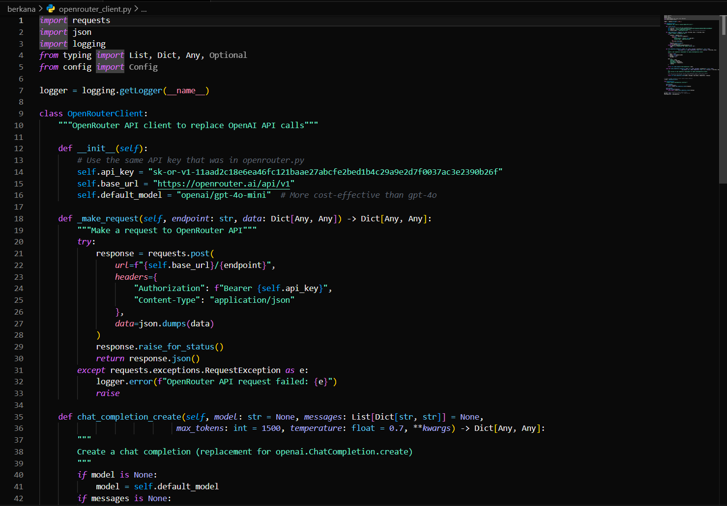
- Vector Store & Memory Scaling
- pgvector or vector store must be efficient in insert/query; index rebalancing, dimension consistency, and pruning older memories are non-trivial.
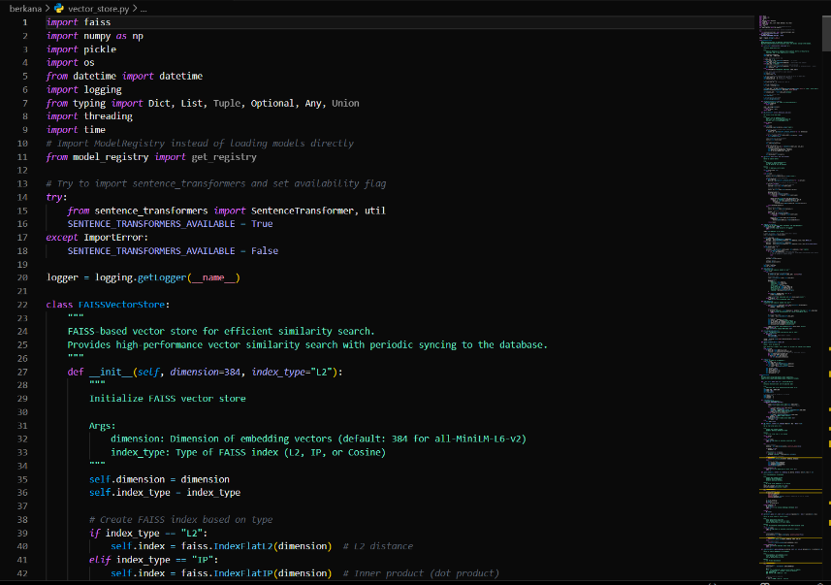
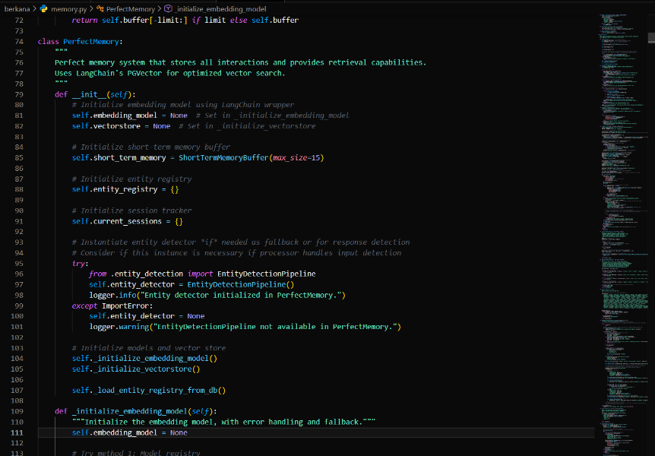

- Model Drift & Re-training Strategy
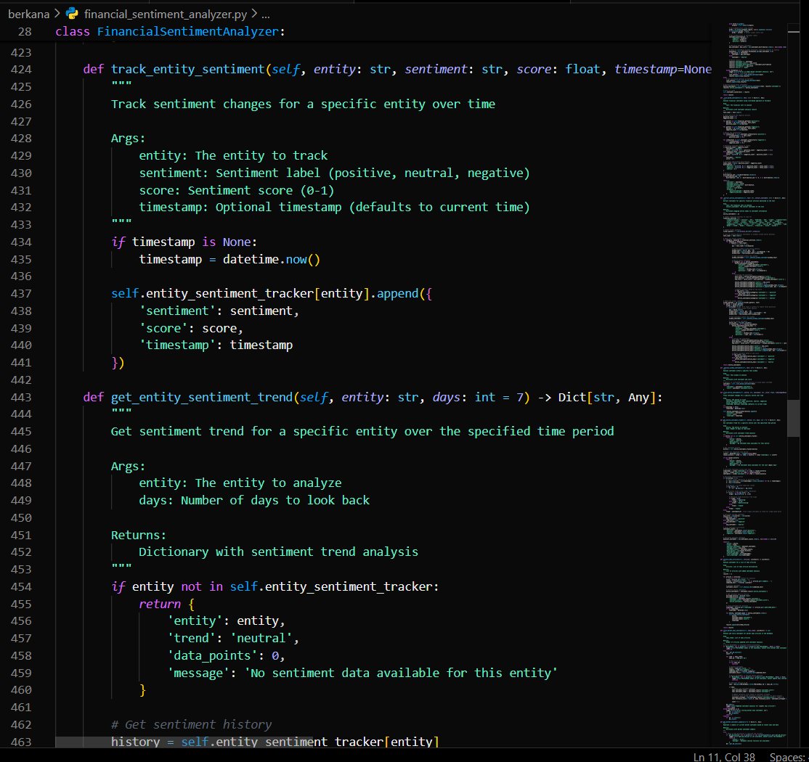
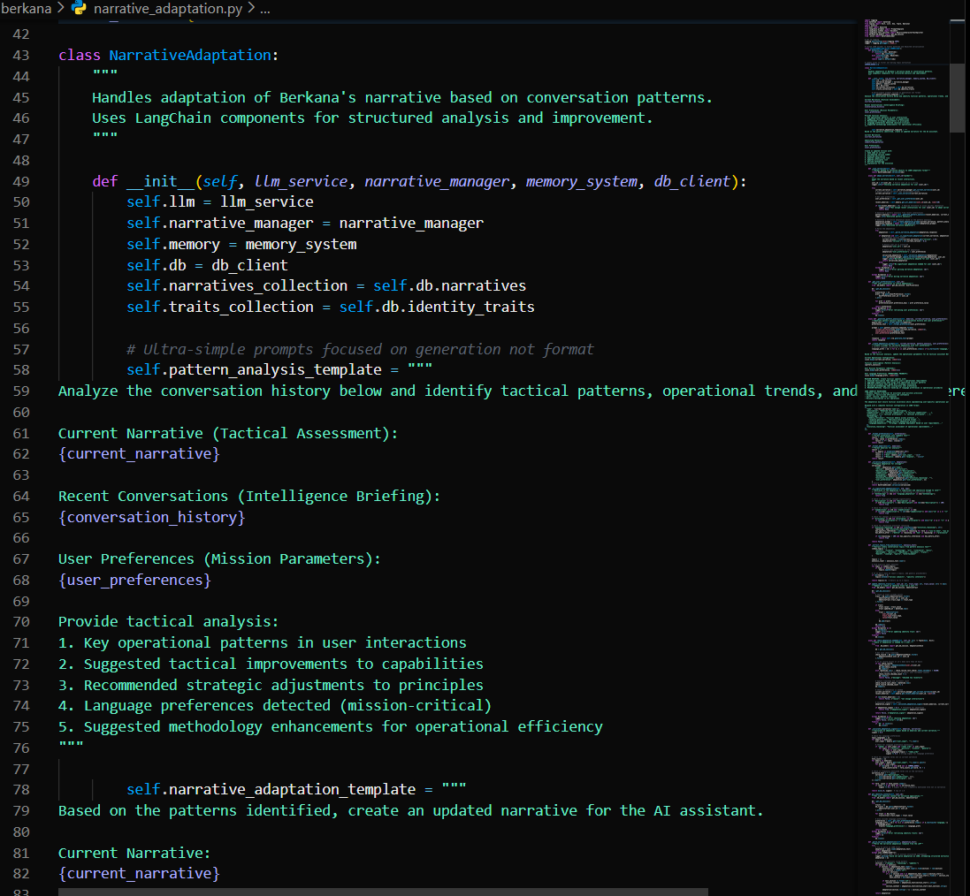
- Sentiment models and entity detectors need retraining using continuous feedback; guard against drift and concept changes.

- Adversarial Inputs and Prompt Injection
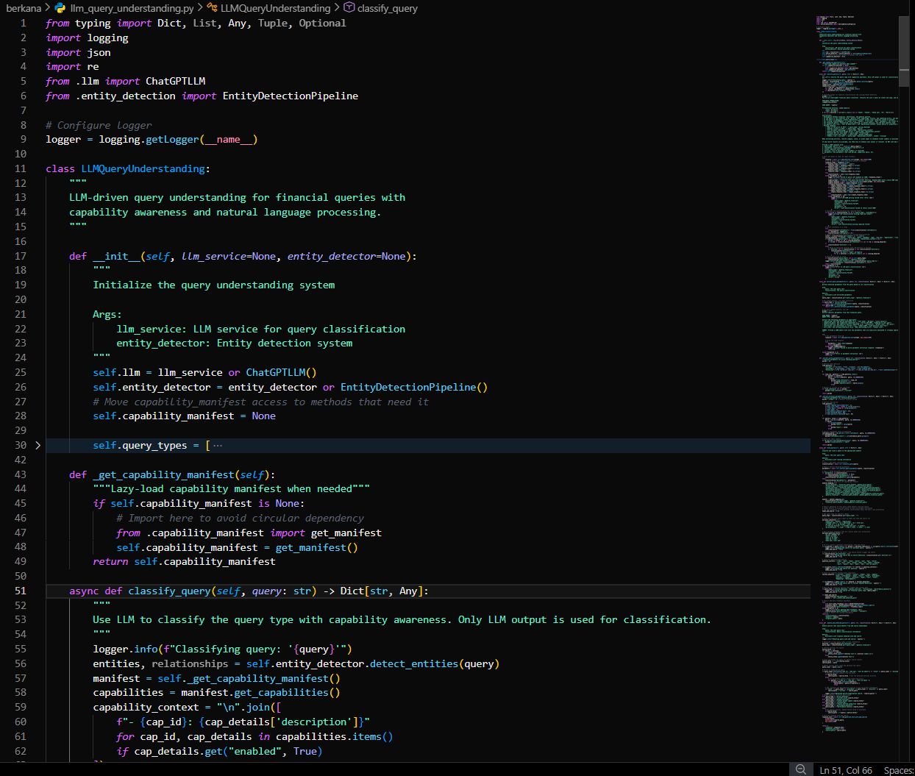
- LLMs and NLP pipelines are susceptible to crafted inputs that change the decision path; implement robust pre- and post- filters.

- Cross-service Failover & API limits
- OpenRouter and market APIS may rate-limit; provide fallback and cached responses.
- Relevant: openrouter.py, market_collector.py.
- Data Protection & Privacy
- Secure PII storage, encryption at rest, opt-out handling.
- Relevant: db_models.py, user.py, preference.py.
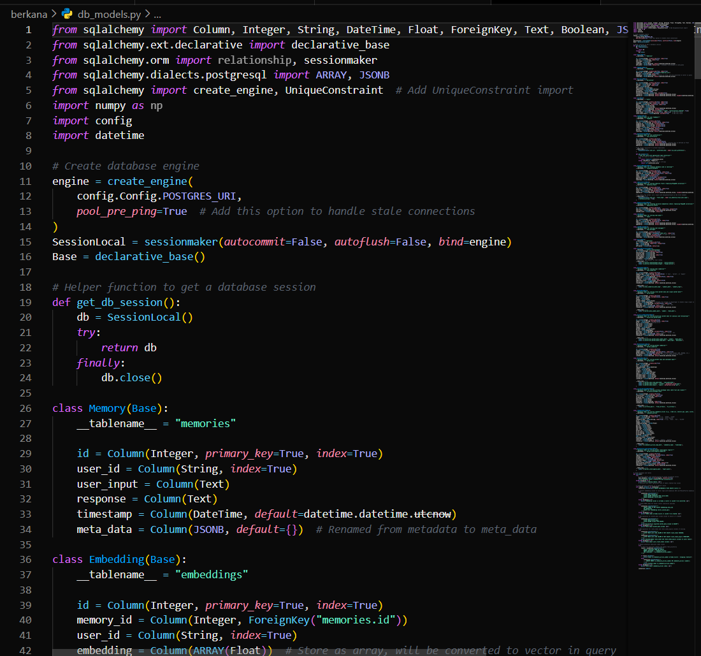

Failure Mode Analysis
At least three distinct failure modes are described below. Each entry contains cause, detection, impact and mitigation.
- Data Ingestion Failure (Loss of External Feed)
- Cause: Market API downtime, network partition, credentials expired.
- Security consequence: Outdated or missing market data leads to stale recommendations; attackers could exploit stale data periods.
- Detection: Alerting on failed requests, exponential backoff and circuit breaker for APIs.
- Mitigation: Local caching, fallback sources, offline mode with audit warnings.
- Model Misclassification or Drift (NLP/Entity/Sentiment mislabel)
- Cause: Distribution shift in news text or market language; adversarial manipulation in the news feed.
- Security consequence: Wrong trading suggestions could cause financial loss; could be exploited to affect user actions.
- Detection: Compare ensemble votes and confidence across models; anomaly detectors and human review triggers for low confidence.
- Mitigation: Ensemble models and retrain pipelines with flagged domain-specific counterexamples; log and roll back to previous models if misbehavior is observed.
- Vector Store or Database Corruption / Downtime
- Cause: Deadlocks, migration failures, hardware disk errors.
- Security consequence: Loss of context memory, incorrect reference for user preferences leading to incorrect suggestions or privacy exposure.
- Detection: DB health checks, transaction failures, schema checks.
- Mitigation: Backups, read-only degraded mode, transactional retries, fallback to local caches.
- LLM Failures / Abusive Prompting
- Cause: Rate limiting, API changes, prompt injection.
- Security consequence: LLM returns misleading or sensitive data leading to privacy breaches or malicious behaviors.
- Detection: Unexpected model responses, token usage spike, or flagged content monitoring.
- Mitigation: Input sanitization, robust prompt design, model response filters, and path to human-in-loop if flagged.
- System Resource Exhaustion
- Cause: Unbounded background tasks or rogue queries.
- Security consequence: Denial of service for legitimate users; potential security exposure when background tasks crash.
- Detection: Metrics and auto-scaling alerts for CPU, memory.
- Mitigation: Queue throttling, resource-limited workers, health-check restarts.

Robustness & Uncertainty
How the model expresses and manages confidence:
- Confidence Scoring Strategy
- Example confidence formula (simplified):
Confidence = (alpha * SentimentCertainty) + (beta * EntityCertainty) + (gamma * MemoryMatchCertainty)
Calibrate alpha/beta/gamma using holdout validation.
- System-Level Protocol for Confidence Thresholds (example)
  - Confidence >= 95% -> AUTO-EXECUTE (trusted suggestions or auto-summarize)
  - 85% <= Confidence < 95% -> SECONDARY VERIFICATION (display strong warnings, require user confirmation for actions)
  - 70% <= Confidence < 85% -> HUMAN REVIEW (enqueue for admin review; append extended logs for audit)
  - Confidence < 70% -> BLOCK + INVESTIGATE (deny automated suggestions; flag as suspicious)

Adversarial Attacks

Context: In Berkana the main adversarial threats are to NLP pipelines and concept-level attacks to distort market sentiment. Examples:
- Intentionally crafted news articles to shift sentiment scoring for a target asset.
- Injection of misleading context in user prompts that causes LLM to leak sensitive information or generate harmful advice.

Adversarial Attack Explanation
- Adversarial attacks seek to change the model’s output by crafting inputs that exploit weaknesses in tokenization, embeddings, or classification decision boundaries.
A method to make the system more robust (Recommendation):
  - Ensemble + Robust Training
    - Train on adversarially-augmented datasets: simulate fake news and insert labels to help the model learn robust features.
  - Input Sanitization & Fact-checking
    - Run a fact verification step (internal or external: knowledge graph, external reliable sources) to cross-check critical assertions before making a recommendation.
  - Detector Network
    - Implement a dedicated adversarial_detector that checks for anomalies in input distribution (sudden bursts of keywords, repetitiveness, or unusual embedding distances) and raises flags.
  - Human-in-the-loop for flagged items
    - When adversarial_detector triggers, move recommendation to admin_review queue.

Ethical Design
Ethical concerns for deployment at a public university focus on fairness, privacy, and transparency.
- Primary ethical issue: Privacy & Data Protection
Berkana may contain sensitive personal finance information or specific preferences. This must be protected by policy and design (encrypt at rest, minimize PII in memory, opt-out policies).
- Policy & Technical mitigations:
  - Data Minimization: Do not store unnecessary PII; use hashed or pseudonymized user IDs in memory tables unless required.
  - Consent & Opt-out: In user.py implement and log user consent. Provide a dashboard to delete user memory (GDPR-style).
  - Access Control & Auditing: Role-based access control with admin/auditor roles. All manual overrides and sensitive queries must be logged with user_id and timestamp.
  - Bias Mitigation: Monitor fairness across demographic subsets. Use counterfactual data augmentation to produce balanced training datasets for the sentiment detector.
  - Transparency: Provide the model’s confidence and explanation (key sentences or evidence documents) in the UI so users understand the recommendation.

CONCLUSION
Berkana AI demonstrates the potential of combining AI, machine learning, and financial data integration in a modular web-based platform. Its scalable architecture, intelligent forecasting, and adaptive visualization make it a reliable solution for market analysis. By addressing the challenges of real-time data processing and contextual query handling, Berkana AI provides a comprehensive tool for investors, analysts, and financial decision-makers.

